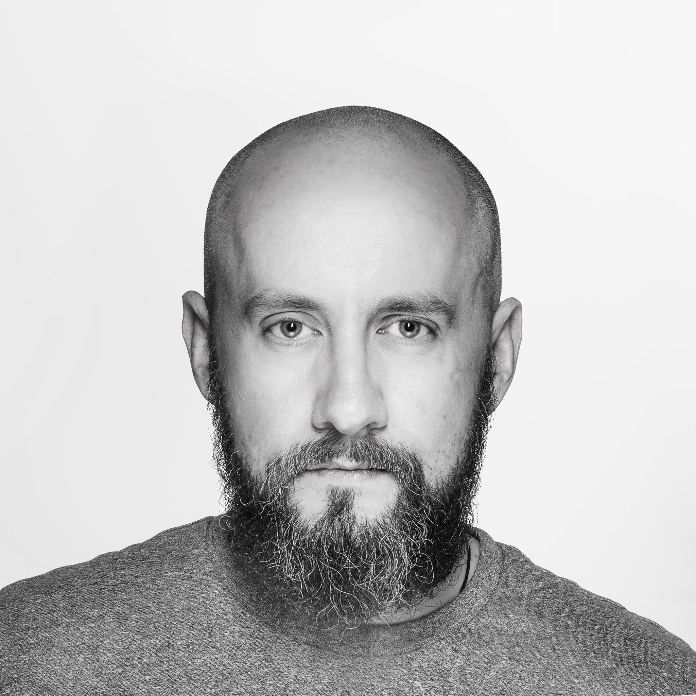
Piotr Szuszkiewicz
address: Gustave-Eiffel-Str. 6, 54294 Trier
mobile: +49 1575 833 15 10
e-mail: piotr.szuszkiewicz@gmail.com

Experience Freelance photographer – Booking.com
Wrocław, Poland - 07.2017 - till now
-Execution of production activities such as photographic shoots, post-processing and delivery;
-Planning the composition of the photographs;
-Analyzing subject material;
-Selection of appropriate equipment, lighting and angle.
-Processing, adjusting and retouching digital files for optimum results;
-Refining existing and developing new photographic techniques and procedures;
-Preparing photographic materials for use on website;
-Delivering photography including GPS data;
Rotom Polska
Środa Śląska – Komorniki, Poland - 03. 2014 - 07.2017
Product Manager – managing online shop for Rotom EU ( 9 countries & languages) and online marketing activities; product photography, descriptions and technical data, photo editing; backend management of the Magento platform; product page design, basic HTML and CSS changes; print design for catalogues, leaflets and brochures; inventory management; product content management, SEO, google analytics and evaluation of sales data; social media management, SalesManago – mailing preparation; graphic projects: 3D animations in Blender, technical drawings of products in Fusion360 and Solid Edge.
Cre8ing Change
Wrocław, Poland - 08.2014 - till now
Owner – professional architecture photographer, indoor & outdoor; event photography, reportage; product photographer for webshops, catalogues and printed marketing materials; night photography, city scapes.
Freelance
Wrocław, Poland - 01.2010 - 08.2014
Professional photographer - events, sport, reportage; graphic designer - logos, brochures and leaflets for small business.
Ruigrok Uitzendbureau BV
Hillegom, Netherland - 10 -11.2012 and 06.2013 - 10.2013
Team manager – transport management, order management, forklift driver.
Piuma Reklama
Opole, Poland - 02.2019 - 09.2011
Graphic designer & sales manager – branding design, logos, leaflets, brochures and business cards, file preparation for printing; photo editing for catalogues and print publications like newspapers; video editing for wall screens, big screen commercials; design and car foil wrapping; account management and sales.

Eniro Polska
Opole, Poland - 06.2009 - 10.2009
Sales Manager – acquiring clients for business catalogs like Yellow Pages/ “Panorama Firm”.
Guesthouse Egilsstadir & Tre Vik
Vik I Myrdal, Iceland – 08.2006 - 10.2009
Facility management – diverse jobs linked to the guesthouse administration & maintenance.

Ultimo
Wrocław Poland– 02.2004 – 06.2006
Debt management – client management; new employee onboarding and training; creating scripts for call-center workers; beta tester for call-center solutions & coordinating the software improvements with developers.
Pro-Asset
Wrocław, Poland– 02.2004 – 04.2004
Customer service representative – customer communication, negotiation of repayments; data management.
Education University of Wrocław
Wrocław - 1997 - 2005
Master of Arts (M.A.) Cell biology and anatomy

Free Code Camp
Virtual course - 12.2016 - in progress
Full Stack Web Development Certification, Computer Software Engineering

UX Design: From Concept to Wireframe -
University of Michigan - virtual course – 05.2017 - in progress

Studium reklamy “Promocja”
Wrocław – 2005 - 2006
Advertising specialist, graphics and photography

Courses
Certificate of Completion: HTML Fundamentals
SoloLearn - virtual course - 09.2016
Licence number 1014-1988172

Creative Best Practices
Facebook – e-learning platform - 09.2016
certificate_168854-39859049

Brand Best Practices
Facebook – e-learning platform - 09.2016
certificate_170276-39993846

A/B Testing
Facebook – e-learning platform - 09.2016
certificate_170313-39994158

Successful Campaigns Best Practices
Facebook – e-learning platform - 09.2016
certificate_170273-41828419

Storytelling With the Carousel Format
Facebook – e-learning platform - 09.2016
certificate_181364-41557745

Made on Mobile: Building Your Business On-the-Go with Facebook and Instagram
Facebook – e-learning platform - 09.2016
certificate_180363-40183390
Graphic Skills Adobe products: Photoshop CC, Lightroom, InDesign, Illustrator, Experience Design, Project Felix
3D software: Blender, Autodesk Fusion360, Cinema 4D
Digital photography, professional middle format digital cameras. Product photography, landscape, outdoor, architecture. Photo editing and print preparation
Programming HTML, HTML5, CSS, CSS3. Basic: MSQL Java and Python

Computer Office, Microsoft office, Word Excel. Google Doc, Libre office, Open office. Linux OS basic

Languages Polish – native
English – advanced
German – basic
Other Driving licence – B
Awards Nikon Photo Contest – Photo of the month – march 2016

Photo of the Week - “40 lat później” obiektywni.pl june 2013

Photo of the Day - PLFOTO - “40 lat później” PLFOTO may 2013

Photo of the Week - “Kryształowe jezioro” PLFOTO may 2013

Photo of the Day - PLFOTO - “Chwila po północy” PLFOTO april 2013

Vox Dei - “40 lat później” – Vox Dei obiektywni.pl march 2013

Daily Deviantation - Deviantart - “My way” august 2008

Photography of the Day - “#8” digart.pl august 2008

Vox Dei - Vox Populi - “Nadejdzie ostatni” obiektywni.pl february 2008

Photography of the Day - “Gleðileg nýtt ár” digart.pl january 2008

Digart Callendar 2008 – cover – digart.pl december 2007
Voluntary Icelandic Red Cross – Rauði krossinn 01.2006 - 10.2008
Red Cross EU Office – blood donator 01.2001 till now
Remote volunteer - traceing satellite imagery into OpenStreetMap
Humanitarian OpenStreetMap Team
Map editor OpenStreetMap Foundation
Remote volunteer - traceing satellite imagery MissingMaps.org

Hobby Orienteering and trail running, photography, cooking and travelling, FSX

Address: Gustave-Eiffel-Str. 6, 54294 Trier • Mobile +49 1575 833 15 10 • E-MAIL piotr.szuszkiewicz@gmail.com

